**INDEX**

**TITLES PAGE NO**

**CONTENTS**

ABSTRACT vi

1. INTRODUCTION 1
2. LITERATURE SURVEY 5
3. SYSTEM ANALYSIS 14
   1. 3.1 EXISTING SYSTEM 16
   2. 3.2 PROPOSEDSYSTEM 16
4. FEASIBILITYSTUDY 17
   1. 4.1 ECONOMICALFEASIBILITY 17
   2. 4.2 TECHNICALFEASIBILITY 17
   3. 4.3 SOCIALFEASIBILITY 18
5. SYSTEMREQUIREMENTS 19

## SYSTEMDESIGN 20

* 1. 6.1 SYSTEMARCHITECTURE 20
  2. 6.2 DATAFLOW DIAGRAM 20
  3. 6.3 UMLDIAGRAMS 22

## IMPLEMENTATION 27

* 1. 7.1 MODULES 27
  2. 7.2 SAMPLE CODE 28

## SYSTEMTESTING 29

* 1. 8.1 UNITTESTING 31
  2. 8.2 INTEGRATION TESTING 32
  3. 8.3 ACCEPTANCETESTING 33

## INPUT DESIGN ANDOUTPUTDESIGN 34

* 1. 9.1 INPUTDESIGN 34
  2. 9.2 OUTPUTDESIGN 35

## SCREENSHOTS 37

## FUTUREWORK 50

## CONCLUSION 51

## BIBLOGRAPHY 52

**ABSTRACT**:

Drowsy driving is one of the major causes of road accidents and death. Hence, detection of driver’s fatigue and its indication is an active research area. Most of the conventional methods are either vehicle based, or behavioral based or physiological based. Few methods are intrusive and distract the driver, some require expensive sensors and data handling. Therefore, in this study, a low cost, real time driver’s drowsiness detection system is developed with acceptable accuracy. In the developed system, a webcam records the video and driver’s face is detected in each frame employing image processing techniques. Facial landmarks on the detected face are pointed and subsequently the eye aspect ratio, mouth opening ratio and nose length ratio are computed and depending on their values, drowsiness is detected based on developed adaptive thresholding. Machine learning algorithms have been implemented as well in an offline manner.

**1. INTRODUCTION**

Drowsy driving is one of the major causes of deaths occurring in road accidents. The truck drivers who drive for continuous long hours (especially at night), bus drivers of long distance route or overnight buses are more susceptible to this problem. Driver drowsiness is an overcast nightmare to passengers in every country. Every year, a large number of injuries and deaths occur due to fatigue related road accidents. Hence, detection of driver’s fatigue and its indication is an active area of research due to its immense practical applicability. The basic drowsiness detection system has three blocks/modules; acquisition system, processing system and warning system. Here, the video of the driver’s frontal face is captured in acquisition system and transferred to the processing block where it is processed online to detect drowsiness. If drowsiness is detected, a warning or alarm is send to the driver from the warning system. Generally, the methods to detect drowsy drivers are classified in three types; vehicle based, behavioural based and physiological based. In vehicle based method, a number of metrics like steering wheel movement, accelerator or brake pattern, vehicle speed, lateral acceleration, deviations from lane position etc. are monitored continuously. Detection of any abnormal change in these values is considered as driver drowsiness. This is a nonintrusive measurement as the sensors are not attached on the driver. In behavioural based method [1- 7], the visual behavior of the driver i.e., eye blinking, eye closing, yawn, head bending etc. are analyzed to detect drowsiness. This is also nonintrusive measurement as simple camera is used to detect these features. In physiological based method [8,9], the physiological signals like Electrocardiogram (ECG), Electooculogram (EOG), Electroencephalogram (EEG), heartbeat, pulse rate etc. are monitored and from these metrics, drowsiness or fatigue level is detected. This is intrusive measurement as the sensors are attached on the driver which will distract the driver. Depending on the sensors used in the system, system cost as well as size will increase. However, inclusion of more parameters/features will increase the accuracy of the system to a certain extent. These factors motivate us to develop a low-cost, real time driver’s drowsiness detection system with acceptable accuracy. Hence, we have proposed a webcam based system to detect driver’s fatigue from the face image only using image processing and machine learning techniques to make the system low-cost as well as portable.

**2. LITERATURE SURVEY**

**2.1 Intelligent Video-Based Drowsy Driver Detection System under Various Illuminations and Embedded Software Implementation**

**Authors:** **Wei-Liang Ou,Ming-Ho Shih,Chien-Wei Chang,Xue-Han Yu,Chih-Peng Fan**

**Abstract:**  An intelligent video-based drowsy driver detection system, which is unaffected by various illuminations, is developed in this study. Even if a driver wears glasses, the proposed system detects the drowsy conditions effectively. By a near-infrared-ray (NIR) camera, the proposed system is divided into two cascaded computational procedures: the driver eyes detection and the drowsy driver detection. The average open/closed eyes detection rates without/with glasses are 94% and 78%, respectively, and the accuracy of the drowsy status detection is up to 91%. By implementing on the FPGA-based embedded platform, the processing speed with the 640×480 format video is up to 16 frames per second (fps) after software optimizations.

**2.2** **Driver Fatigue Detection based on Eye Tracking and Dynamic Template Matching**

**Authors:** W. B. Horng, C. Y. Chen, Y. Chang, C. H. Fan

**Abstract:**  A vision-based real-time driver fatigue detection system is proposed for driving safely. The driver's face is located, from color images captured in a car, by using the characteristic of skin colors. Then, edge detection is used to locate the regions of eyes. In addition to being used as the dynamic templates for eye tracking in the next frame, the obtained eyes' images are also used for fatigue detection in order to generate some warning alarms for driving safety. The system is tested on a Pentium III 550 CPU with 128 MB RAM. The experiment results seem quite encouraging andpromising. The system can reach 20 frames per second for eye tracking, and the average correct rate for eye location and tracking can achieve 99.1% on four test videos. The correct rate for fatigue detection is l00%, but the average precision rate is 88.9% on the test videos.

# 2.3 Monitoring Driver Fatigue using Facial Analysis Techniques

**Authors:** S. Singh, N. P. papanikolopoulos **Abstract:** In this paper, we describe a non-intrusive vision-based system for the detection of driver fatigue. The system uses a color video camera that points directly rewards the driver's face and monitors the driver's eyes in order to detect micro-sleeps (short periods of sleep). The system deals with skin-color information in order to search for the face in the input space. After segmenting the pixels with skin like color, we perform blob processing in order to determine the exact position of the face. We reduce the search space by analyzing the horizontal gradient map of the face, taking into account the knowledge that eye regions in the face present a great change in the horizontal intensity gradient. In order to find and track the location of the pupil, we use gray scale model matching. We also use the same pattern recognition technique to determine whether the eye is open or closed. If the eyes remain closed for an abnormal period of time (5-6 sec), the system draws the conclusion that the person is falling asleep and issues a warning signal.

# 2.4 Driver drowsiness detection system

**Authors: Belal Alshaqaqi,Abdullah Salem Baquhaizel,Mohamed El Amine Ouis,Meriem Boumehed**

**Abstract:** Drowsiness and Fatigue of drivers are amongst the significant causes of road accidents. Every year, they increase the amounts of deaths and fatalities injuries globally. In this paper, a module for Advanced Driver Assistance System (ADAS) is presented to reduce the number of accidents due to drivers fatigue and hence increase the transportation safety; this system deals with automatic driver drowsiness detection based on visual information and Artificial Intelligence. We propose an algorithm to locate, track, and analyze both the drivers face and eyes to measure PERCLOS, a scientifically supported measure of drowsiness associated with slow eye closure.

**2.5 SOFTWARE ENVIRONMENT**

**Python** is a high-level, interpreted scripting language developed in the late 1980s by Guido van Rossum at the National Research Institute for Mathematics and Computer Science in the Netherlands. The initial version was published at the alt. Sources [newsgroup](https://en.wikipedia.org/wiki/Usenet) in 1991, and version 1.0 was released in 1994.

Python 2.0 was released in 2000, and the 2.x versions were the prevalent releases until December 2008. At that time, the development team made the decision to release version 3.0, which contained a few relatively small but significant changes that were not backward compatible with the 2.x versions. Python 2 and 3 are very similar, and some features of Python 3 have been back ported to Python 2. But in general, they remain not quite compatible.

Both Python 2 and 3 have continued to be maintained and developed, with periodic release updates for both. As of this writing, the most recent versions available are 2.7.15 and 3.6.5. However, an official [End of Life date of January 1, 2020](https://pythonclock.org/) has been established for Python 2, after which time it will no longer be maintained. If you are a newcomer to Python, it is recommended that you focus on Python 3, as this tutorial will do.

Python is still maintained by a core development team at the Institute, and Guido is still in charge, having been given the title of BDFL (Benevolent Dictator For Life) by the Python community. The name Python, by the way, derives not from the snake, but from the British comedy troupe [Monty Python’s Flying Circus](https://en.wikipedia.org/wiki/Monty_Python%27s_Flying_Circus), of which Guido was, and presumably still is, a fan. It is common to find references to Monty Python sketches and movies scattered throughout the Python documentation.

**2.6 WHY CHOOSE PYTHON**

If you’re going to write programs, there are literally dozens of commonly used languages to choose from. Why choose Python? Here are some of the features that make Python an appealing choice.

**Python is Popular**

Python has been growing in popularity over the last few years. The 2018 [Stack Overflow Developer Survey](https://insights.stackoverflow.com/survey/2018) ranked Python as the 7th most popular and the number one most wanted technology of the year. [World-class software development countries around the globe use Python every single day.](https://realpython.com/world-class-companies-using-python/)

According to [research by Dice](https://insights.dice.com/2016/02/01/whats-hot-and-not-in-tech-skills/) Python is also one of the hottest skills to have and the most popular programming language in the world based on the [Popularity of Programming Language Index](https://pypl.github.io/PYPL.html).

Due to the popularity and widespread use of Python as a programming language, Python developers are sought after and paid well. If you’d like to dig deeper into [Python salary statistics and job opportunities, you can do so here](https://dbader.org/blog/why-learn-python).

**Python is interpreted**

Many languages are compiled, meaning the source code you create needs to be translated into machine code, the language of your computer’s processor, before it can be run. Programs written in an interpreted language are passed straight to an interpreter that runs them directly.

This makes for a quicker development cycle because you just type in your code and run it, without the intermediate compilation step.

One potential downside to interpreted languages is execution speed. Programs that are compiled into the native language of the computer processor tend to run more quickly than interpreted programs. For some applications that are particularly computationally intensive, like graphics processing or intense number crunching, this can be limiting.

In practice, however, for most programs, the difference in execution speed is measured in milliseconds, or seconds at most, and not appreciably noticeable to a human user. The expediency of coding in an interpreted language is typically worth it for most applications.

### Python is Free

The Python interpreter is developed under an OSI-approved open-source license, making it free to install, use, and distribute, even for commercial purposes.

A version of the interpreter is available for virtually any platform there is, including all flavors of Unix, Windows, macOS, smart phones and tablets, and probably anything else you ever heard of. A version even exists for the half dozen people remaining who use OS/2.

### Python is Portable

Because Python code is interpreted and not compiled into native machine instructions, code written for one platform will work on any other platform that has the Python interpreter installed. (This is true of any interpreted language, not just Python.)

### Python is Simple

As programming languages go, Python is relatively uncluttered, and the developers have deliberately kept it that way.

A rough estimate of the complexity of a language can be gleaned from the number of keywords or reserved words in the language. These are words that are reserved for special meaning by the compiler or interpreter because they designate specific built-in functionality of the language.

Python 3 has 33 keywords, and Python 2 has 31. By contrast, C++ has 62, Java has 53, and Visual Basic has more than 120, though these latter examples probably vary somewhat by implementation or dialect.

Python code has a simple and clean structure that is easy to learn and easy to read. In fact, as you will see, the language definition enforces code structure that is easy to read.

But It’s Not That Simple For all its syntactical simplicity, Python supports most constructs that would be expected in a very high-level language, including complex dynamic data types, structured and functional programming, and [object-oriented programming](https://realpython.com/python3-object-oriented-programming/).

Additionally, a very extensive library of classes and functions is available that provides capability well beyond what is built into the language, such as database manipulation or GUI programming.

Python accomplishes what many programming languages don’t: the language itself is simply designed, but it is very versatile in terms of what you can accomplish with it.

## Conclusion

This section gave an overview of the **Python** programming language, including:

* A brief history of the development of Python
* Some reasons why you might select Python as your language of choice

Python is a great option, whether you are a beginning programmer looking to learn the basics, an experienced programmer designing a large application, or anywhere in between. The basics of Python are easily grasped, and yet its capabilities are vast. Proceed to the next section to learn how to acquire and install Python on your computer.

**Python** is an [open source](https://simple.wikipedia.org/wiki/Open_source) [programming language](https://simple.wikipedia.org/wiki/Programming_language) that was made to be easy-to-read and powerful. A [Dutch](https://simple.wikipedia.org/wiki/Netherlands) programmer named [Guido van Rossum](https://simple.wikipedia.org/wiki/Guido_van_Rossum) made Python in 1991. He named it after the television show [Monty Python's Flying Circus](https://simple.wikipedia.org/wiki/Monty_Python%27s_Flying_Circus). Many Python examples and tutorials include jokes from the show.

Python is an interpreted language. Interpreted languages do not need to be [compiled](https://simple.wikipedia.org/wiki/Compiled_language) to run. A program called an [interpreter](https://simple.wikipedia.org/wiki/Interpreter_(computing)) runs Python code on almost any kind of computer. This means that a programmer can change the code and quickly see the results. This also means Python is slower than a compiled language like [C](https://simple.wikipedia.org/wiki/C_(programming_language)), because it is not running [machine code](https://simple.wikipedia.org/wiki/Machine_code) directly.

Python is a good programming language for beginners. It is a high-level language, which means a programmer can focus on what to do instead of how to do it. Writing programs in Python takes less time than in some other languages.

Python drew inspiration from other programming languages like C, [C++](https://simple.wikipedia.org/wiki/C%2B%2B), [Java](https://simple.wikipedia.org/wiki/Java_(programming_language)), [Perl](https://simple.wikipedia.org/wiki/Perl), and [Lisp](https://simple.wikipedia.org/wiki/LISP).

Python has a very easy-to-read syntax. Some of Python's syntax comes from C, because that is the language that Python was written in. But Python uses whitespace to delimit code: spaces or tabs are used to organize code into groups. This is different from C. In C, there is a [semicolon](https://simple.wikipedia.org/wiki/Semicolon) at the end of each line and curly braces ({}) are used to group code. Using whitespace to delimit code makes Python a very easy-to-read language.

**Python use [change / change source]**

Python is used by hundreds of thousands of programmers and is used in many

places. Sometimes only Python code is used for a program, but most of the time it is used to do simple jobs while another programming language is used to do more complicated tasks.

Its [standard library](https://simple.wikipedia.org/w/index.php?title=Standard_library&action=edit&redlink=1) is made up of many [functions](https://simple.wikipedia.org/wiki/Computable_function) that come with Python when it is installed. On the [Internet](https://simple.wikipedia.org/wiki/Internet) there are many other [libraries](https://simple.wikipedia.org/w/index.php?title=Library_(computing)&action=edit&redlink=1) available that make it possible for the Python language to do more things. These libraries make it a powerful language; it can do many different things.

Some things that Python is often used for are:

* Web development
* Scientific programming
* Desktop [GUIs](https://simple.wikipedia.org/wiki/GUI)
* Network programming
* [Game](https://simple.wikipedia.org/wiki/Video_game) programming

**3. SYSTEM ANALYSIS**

**3.1 EXISTING SYSTEM:**

Traffic congestion is one of the major modern-day crises in every big city in the world. Previously different techniques had been proposed, such as infra-red light sensor, induction loop etc. to acquire traffic date which had their fair share of demerits. In recent years, image processing has shown promising outcomes in acquiring real time traffic information using CCTV footage installed along the traffic light. Different approaches have been proposed to glean traffic data. Some of them count total number of pixels, some of the work calculate number of vehicles. These methods have shown promising results in collecting traffic data. However, calculating the number of vehicles may give false results if the intra vehicular spacing is very small (two vehicles close to each other may be counted as one) and it may not count rickshaw or auto-rickshaw as vehicles which are the quotidian means of traffic especially in South-Asian countries.

**DISADVANTAGES OF EXISTING SYSTEM:**

1. Traffic congestion is one of the head ach. Here using infra-red light sensor to detect traffic.

**3.2 PROPOSED SYSTEM:**

In this paper, a system in which density of traffic is measured by comparing captured image with real time traffic information against the image of the empty road as reference image is proposed. Each lane will have a minimum amount of green signal duration allocated. According to the percentage of matching allocated traffic light duration can be controlled.

**ADVANTAGES OF PROPOSED SYSTEM:**

1. Minimum amount of green signal duration allocated. According to the percentage of matching allocated traffic light duration can be controlled.

**4. FEASIBILITY STUDY**

The feasibility of the project is analyzed in this phase and business proposal is put forth with a very general plan for the project and some cost estimates. During system analysis the feasibility study of the proposed system is to be carried out. This is to ensure that the proposed system is not a burden to the company. For feasibility analysis, some understanding of the major requirements for the system is essential.

Three key considerations involved in the feasibility analysis are

* ECONOMICAL FEASIBILITY
* TECHNICAL FEASIBILITY
* SOCIAL FEASIBILITY

**4.1 ECONOMICAL FEASIBILITY**

This study is carried out to check the economic impact that the system will have on the organization. The amount of fund that the company can pour into the research and development of the system is limited. The expenditures must be justified. Thus the developed system as well within the budget and this was achieved because most of the technologies used are freely available. Only the customized products had to be purchased.

**4.2 TECHNICAL FEASIBILITY**

This study is carried out to check the technical feasibility, that is, the technical requirements of the system. Any system developed must not have a high demand on the available technical resources. This will lead to high demands on the available technical resources. This will lead to high demands being placed on the client. The developed system must have a modest requirement, as only minimal or null changes are required for implementing this system.

**4.3 SOCIAL FEASIBILITY**

The aspect of study is to check the level of acceptance of the system by the user. This includes the process of training the user to use the system efficiently. The user must not feel threatened by the system, instead must accept it as a necessity. The level of acceptance by the users solely depends on the methods that are employed to educate the user about the system and to make him familiar with it. His level of confidence must be raised so that he is also able to make some constructive criticism, which is welcomed, as he is the final user of the system.

**5. SYSTEM REQUIREMENTS**

**5.1 HARDWARE REQUIREMENTS:**

* System : Pentium Dual Core.
* Hard Disk : 120 GB.
* Monitor : 15’’ LED
* Input Devices : Keyboard, Mouse
* Ram : 1 GB

**5.2 SOFTWARE REQUIREMENTS:**

* Operating system : Windows 10
* Coding Language : python
* Tool : PyCharm
* Database : MYSQL
* Server : Flask

**6. SYSTEM DESIGN**

**6.1 SYSTEM ARCHITECTURE:**

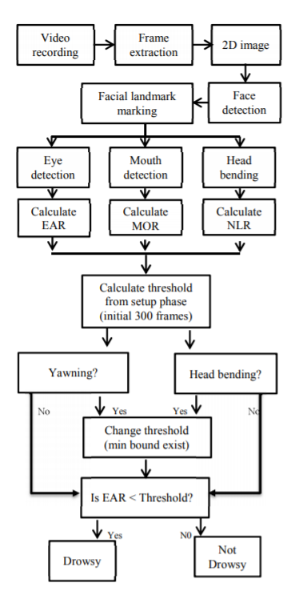

**6.2 DATA FLOW DIAGRAM:**

1. The DFD is also called as bubble chart. It is a simple graphical formalism that can be used to represent a system in terms of input data to the system, various processing carried out on this data, and the output data is generated by this system.
2. The data flow diagram (DFD) is one of the most important modeling tools. It is used to model the system components. These components are the system process, the data used by the process, an external entity that interacts with the system and the information flows in the system.
3. DFD shows how the information moves through the system and how it is modified by a series of transformations. It is a graphical technique that depicts information flow and the transformations that are applied as data moves from input to output.
4. DFD is also known as bubble chart. A DFD may be used to represent a system at any level of abstraction. DFD may be partitioned into levels that represent increasing information flow and functional detail.

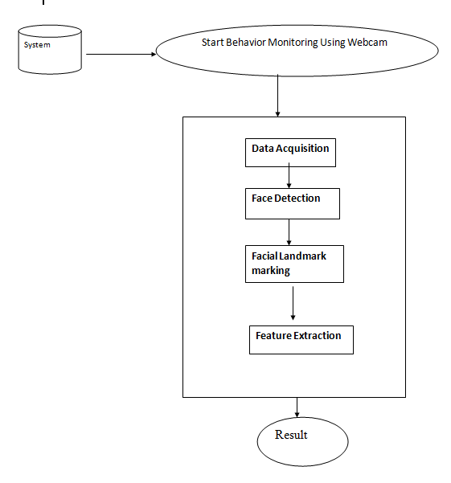

**6.3 UML DIAGRAMS:**

UML stands for Unified Modeling Language. UML is a standardized general-purpose modeling language in the field of object-oriented software engineering. The standard is managed, and was created by, the Object Management Group.

The goal is for UML to become a common language for creating models of object oriented computer software. In its current form UML is comprised of two major components: a Meta-model and a notation. In the future, some form of method or process may also be added to; or associated with, UML.

The Unified Modeling Language is a standard language for specifying, Visualization, Constructing and documenting the artifacts of software system, as well as for business modeling and other non-software systems.

The UML represents a collection of best engineering practices that have proven successful in the modeling of large and complex systems.

The UML is a very important part of developing objects oriented software and the software development process. The UML uses mostly graphical notations to express the design of software projects.

**GOALS:**

The Primary goals in the design of the UML are as follows:

1. Provide users a ready-to-use, expressive visual modeling Language so that they can develop and exchange meaningful models.
2. Provide extendibility and specialization mechanisms to extend the core concepts.
3. Be independent of particular programming languages and development process.
4. Provide a formal basis for understanding the modeling language.
5. Encourage the growth of OO tools market.
6. Integrate best practices.

**USE CASE DIAGRAM:**

A use case diagram in the Unified Modeling Language (UML) is a type of behavioral diagram defined by and created from a Use-case analysis. Its purpose is to present a graphical overview of the functionality provided by a system in terms of actors, their goals (represented as use cases), and any dependencies between those use cases. The main purpose of a use case diagram is to show what system functions are performed for which actor. Roles of the actors in the system can bedepicted.

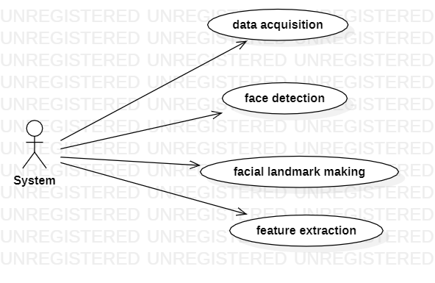

**CLASS DIAGRAM:**

In software engineering, a class diagram in the Unified Modeling Language (UML) is a type of static structure diagram that describes the structure of a system by showing the system's classes, their attributes, operations (or methods), and the relationships among the classes. It explains which class contains information.

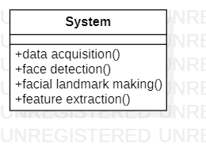

**SEQUENCE DIAGRAM:**

A sequence diagram in Unified Modeling Language (UML) is a kind of interaction diagram that shows how processes operate with one another and in what order. It is a construct of a Message Sequence Chart. Sequence diagrams are sometimes called event diagrams, event scenarios, and timing diagrams.

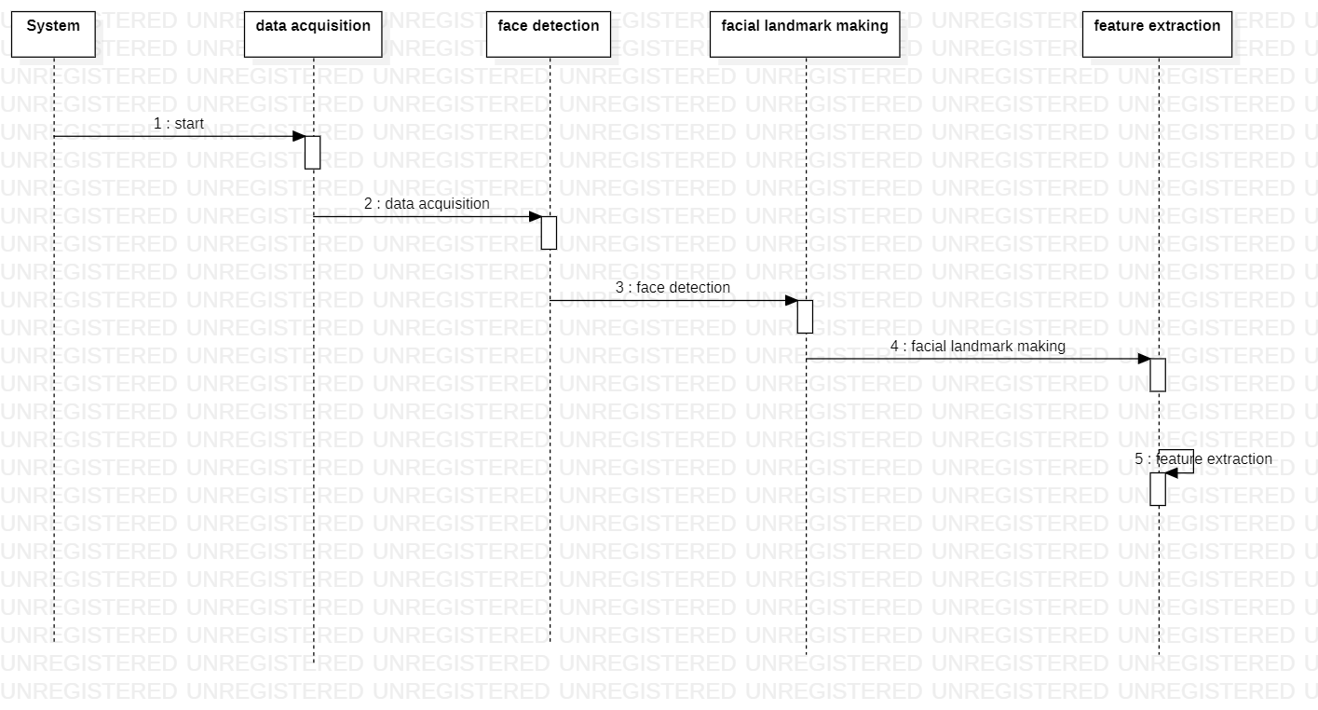

**ACTIVITY DIAGRAM:**

Activity diagrams are graphical representations of workflows of stepwise activities and actions with support for choice, iteration and concurrency. In the Unified Modeling Language, activity diagrams can be used to describe the business and operational step-by-step workflows of components in a system. An activity diagram shows the overall flow of control.

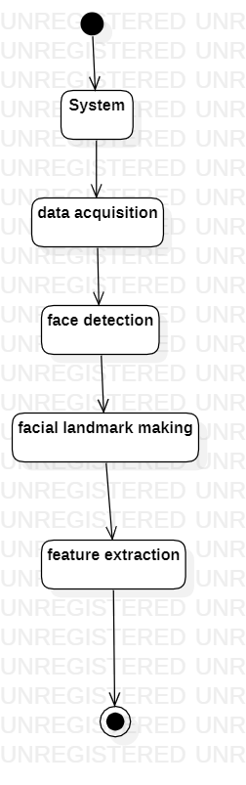

**7. IMPLEMENTATION**

**7.1 MODULES:**

* **Data Acquisition**
* **Face Detection**
* **Facial Landmark marking**
* **Feature Extraction**
* **Classification**

**MODULES DESCRIPTION:**

**Data Acquisition :-**

The video is recorded using webcam (Sony CMU-BR300) and the frames are extracted and processed in a laptop. After extracting the frames, image processing techniques are applied on these 2D images. Presently, synthetic driver data has been generated. The volunteers are asked to look at the webcam with intermittent eye blinking, eye closing, yawning and head bending. The video is captured for 30 minutes duration.

**Face Detection :-**

After extracting the frames, first the human faces are detected. Numerous online face detection algorithms are there. In this study, histogram of oriented gradients (HOG) and linear SVM method [10] is used. In this method, positive samples of descriptors are computed on them. Subsequently, negative samples (samples that do not contain the required object to be detected i.e., human face here) of same size are taken and HOG descriptors are calculated. Usually the number of negative samples is very greater than number of positive samples. After obtaining the features for both the classes, a linear SVM is trained for the classification task. To improve the accuracy of VM, hard negative mining is used. In this method, after training, the classifier is tested on the labeled data and the false positive sample feature values are used again for training

purpose. For the test image, the fixed size window is translated over the image and the classifier computes the output for each window location. Finally, the maximum value output is considered as the detected face and a bounding box is drawn around the face. This non-maximum suppression step removes the redundant and overlapping bounding boxes.

**Facial Landmark marking :-**

After detecting the face, the next task is to find the locations of different facial features like the corners of the eyes and mouth, the tip of the nose and so on. Prior to that, the face images should be normalized in order to reduce the effect of distance from the camera, non-uniform illumination and varying image resolution. Therefore, the face image is resized to a width of 500 pixels and converted to grayscale image. After image normalization, ensemble of regression trees [11] is used to estimate the landmark positions on face from a sparse subset of pixel intensities. In this method, the sum of square error loss is optimized using gradient boosting learning. Different priors are used to find different structures. Using this method, the boundary points of eyes, mouth and the central line of the nose are marked and the number of points for eye, mouth and nose are given in Table I. The facial landmarks are shown in Fig 2. The red points are the detected landmarks for further processing.

**D. Feature Extraction**

After detecting the facial landmarks, the features are computed as described below. Eye aspect ratio (EAR): From the eye corner points, the eye aspect ratio is calculated as the ratio of height and width of the eye as given by

**Classification :-**

After computing all the three features, the next task is to detect drowsiness in the extracted frames. In the beginning, adaptive thresholding is considered for classification. Later, machine learning algorithms are used to classify the data. For computing the threshold values for each feature, it is assumed that initially the driver is in complete awake state. This is called setup phase. In the setup phase, the EAR values for first three hundred (for 10s at 30 fps) frames are recorded. Out 4of these three hundred initial frames containing face, average of 150 maximum values is considered as the hard threshold for EAR. The higher values are considered so that no eye closing instances will be present. If the test value is less than this threshold, then eye closing (i.e., drowsiness) is detected. As the size of eye can vary from person to person, this initial setup for each person will reduce this effect. Similarly, for calculating threshold of MOR, since the mouth may not be open to its maximum in initial frames (setup phase) so the threshold is taken experimentally from the observations. If the test value is greater than this threshold then yawn (i.e., drowsiness) is detected. Head bending feature is used to find the angle made by head with respect to vertical axis in terms of ratio of projected nose lengths. Normally, NLR has values rom 0.9 to 1.1 for normal upright position of head and it increases or decreases when head bends down or up in the state of drowsiness. The average nose length is computed as the average of the nose lengths in the setup phase assuming that no head bending is there. After computing the threshold values, the system is used for testing. The system detects the drowsiness if in a test frame drowsiness is detected for at least one feature. To make this thresholding more realistic, the decision for each frame depends on the last 75 frames. If at least 70 frames (out of those 75) satisfy drowsiness conditions for at least one feature, then the system gives drowsiness detection indication and the alarm.

**7.2 SAMPLE CODE**

### 8. SYSTEM TESTING

The purpose of testing is to discover errors. Testing is the process of trying to discover every conceivable fault or weakness in a work product. It provides a way to check the functionality of components, sub assemblies, assemblies and/or a finished product It is the process of exercising software with the intent of ensuring that the Software system meets its requirements and user expectations and does not fail in an unacceptable manner. There are various types of test. Each test type addresses a specific testing requirement.

**TYPES OF TESTS**

**Unit testing:**

Unit testing involves the design of test cases that validate that the internal program logic is functioning properly, and that program inputs produce valid outputs. All decision branches and internal code flow should be validated. It is the testing of individual software units of the application .it is done after the completion of an individual unit before integration. This is a structural testing, that relies on knowledge of its construction and is invasive. Unit tests perform basic tests at component level and test a specific business process, application, and/or system configuration. Unit tests ensure that each unique path of a business process performs accurately to the documented specifications and contains clearly defined inputs and expected results.

**Integration testing:**

Integration tests are designed to test integrated software components to determine if they actually run as one program. Testing is event driven and is more concerned with the basic outcome of screens or fields. Integration tests demonstrate that although the components were individually satisfaction, as shown by successfully unit testing, the combination of components is correct and consistent. Integration testing is specifically aimed at exposing the problems that arise from the combination of components.

**Functional test:**

Functional tests provide systematic demonstrations that functions tested are available as specified by the business and technical requirements, system documentation, and user manuals.

Functional testing is centered on the following items:

Valid Input : identified classes of valid input must be accepted.

Invalid Input : identified classes of invalid input must be rejected.

Functions : identified functions must be exercised.

Output : identified classes of application outputs must be exercised.

Systems/Procedures : interfacing systems or procedures must be invoked.

Organization and preparation of functional tests is focused on requirements, key functions, or special test cases. In addition, systematic coverage pertaining to identify Business process flows; data fields, predefined processes, and successive processes must be considered for testing. Before functional testing is complete, additional tests are identified and the effective value of current tests is determined.

**System Test:**

System testing ensures that the entire integrated software system meets requirements. It tests a configuration to ensure known and predictable results. An example of system testing is the configuration oriented system integration test. System testing is based on process descriptions and flows, emphasizing pre-driven process links and integration points.

**White Box Testing:**

White Box Testing is a testing in which in which the software tester has knowledge of the inner workings, structure and language of the software, or at least its purpose. It is purpose. It is used to test areas that cannot be reached from a black box level.

**Black Box Testing:**

Black Box Testing is testing the software without any knowledge of the inner workings, structure or language of the module being tested. Black box tests, as most other kinds of tests, must be written from a definitive source document, such as specification or requirements document, such as specification or requirements document. It is a testing in which the software under test is treated, as a black box .you cannot “see” into it. The test provides inputs and responds to outputs without considering how the software works.

**8.1 Unit Testing:**

Unit testing is usually conducted as part of a combined code and unit test phase of the software lifecycle, although it is not uncommon for coding and unit testing to be conducted as two distinct phases.

**Test strategy and approach:**

Field testing will be performed manually and functional tests will be written in detail.

**Test objectives:**

* All field entries must work properly.
* Pages must be activated from the identified link.
* The entry screen, messages and responses must not be delayed.

**Features to be tested**

* Verify that the entries are of the correct format
* No duplicate entries should be allowed
* All links should take the user to the correct page.

# 8.2 Integration Testing

Software integration testing is the incremental integration testing of two or more integrated software components on a single platform to produce failures caused by interface defects.

The task of the integration test is to check that components or software applications, e.g. components in a software system or – one step up – software applications at the company level – interact without error.

**Test Results:** All the test cases mentioned above passed successfully. No defects encountered.

**8.3 Acceptance Testing**

User Acceptance Testing is a critical phase of any project and requires significant participation by the end user. It also ensures that the system meets the functional requirements.

**Test Results:** All the test cases mentioned above passed successfully. No defects encountered.

**9. INPUT DESIGN AND OUTPUT DESIGN**

**9.1 INPUT DESIGN:**

The input design is the link between the information system and the user. It comprises the developing specification and procedures for data preparation and those steps are necessary to put transaction data in to a usable form for processingcan be achieved by inspecting the computer to read data from a written or printed document or it can occur by having people keying the data directly into the system. The design of input focuses on controlling the amount of input required, controlling the errors, avoiding delay, avoiding extra steps and keeping the process simple. The input is designed in such a way so that it provides security and ease of use with retaining the privacy. Input Design considered the following things:

* What data should be given as input?
* How the data should be arranged or coded?
* The dialog to guide the operating personnel in providing input.
* Methods for preparing input validations and steps to follow when error occur.

**OBJECTIVES:**

1. Input Design is the process of converting a user-oriented description of the input into a computer-based system. This design is important to avoid errors in the data input process and show the correct direction to the management for getting correct information from the computerized system.

2.It is achieved by creating user-friendly screens for the data entry to handle large volume of data. The goal of designing input is to make data entry easier and to be free from errors. The data entry screen is designed in such a way that all the data manipulates can be performed. It also provides record viewing facilities.

3. When the data is entered it will check for its validity. Data can be entered with the help of screens. Appropriate messages are provided as when needed so that the user will not be in maize of instant. Thus the objective of input design is to create an input layout that is easy to follow

**9.2 OUTPUT DESIGN:**

A quality output is one, which meets the requirements of the end user and presents the information clearly. In any system results of processing are communicated to the users and to other system through outputs. In output design it is determined how the information is to be displaced for immediate need and also the hard copy output. It is the most important and direct source information to the user. Efficient and intelligent output design improves the system’s relationship to help user decision-making.

1. Designing computer output should proceed in an organized, well thought out manner; the right output must be developed while ensuring that each output element is designed so that people will find the system can use easily and effectively. When analysis design computer output, they should Identify the specific output that is needed to meet the requirements.

2. Select methods for presenting information.

3. Create document, report, or other formats that contain information produced by the system.

The output form of an information system should accomplish one or more of the following objectives.

* Convey information about past activities, current status or projections of the
* Future.
* Signal important events, opportunities, problems, or warnings.
* Trigger an action.
* Confirm an action.

**10. SCREENSHOTS**

To run this project double click on ‘run.bat’ file to get below screen

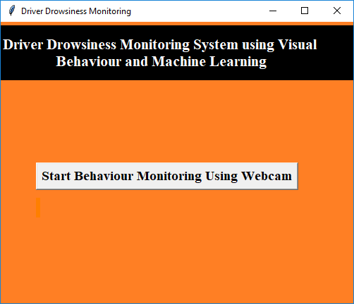

In above screen click on ‘Start Behaviour Monitoring Using Webcam’ button to connect application with webcam, after clicking button will get below screen with webcam streaming

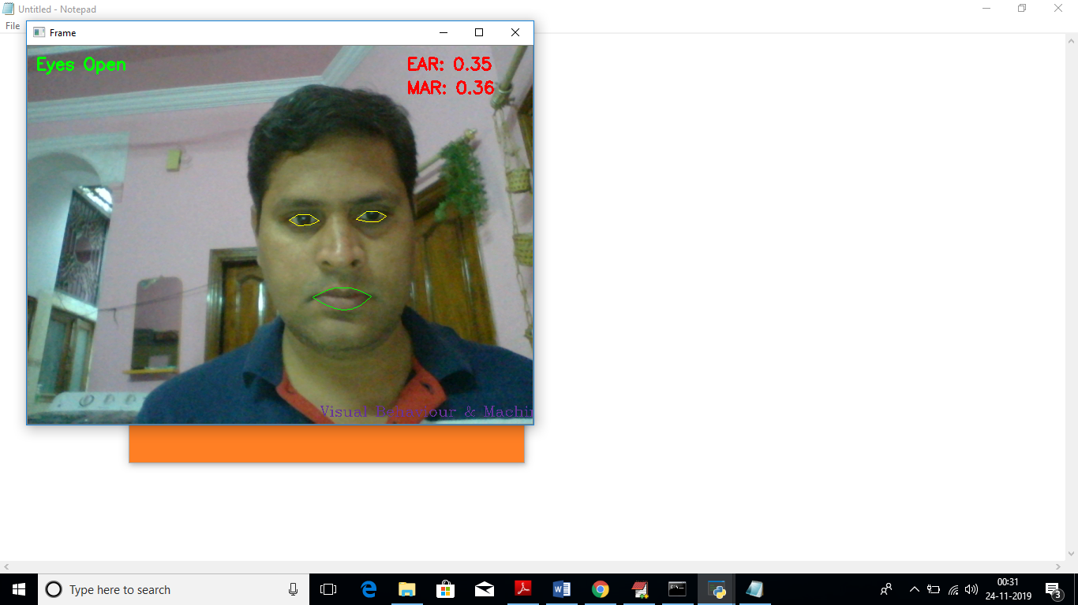

In above screen we can see web cam stream then application monitor all frames to see person eyes are open or not, if closed then will get below message

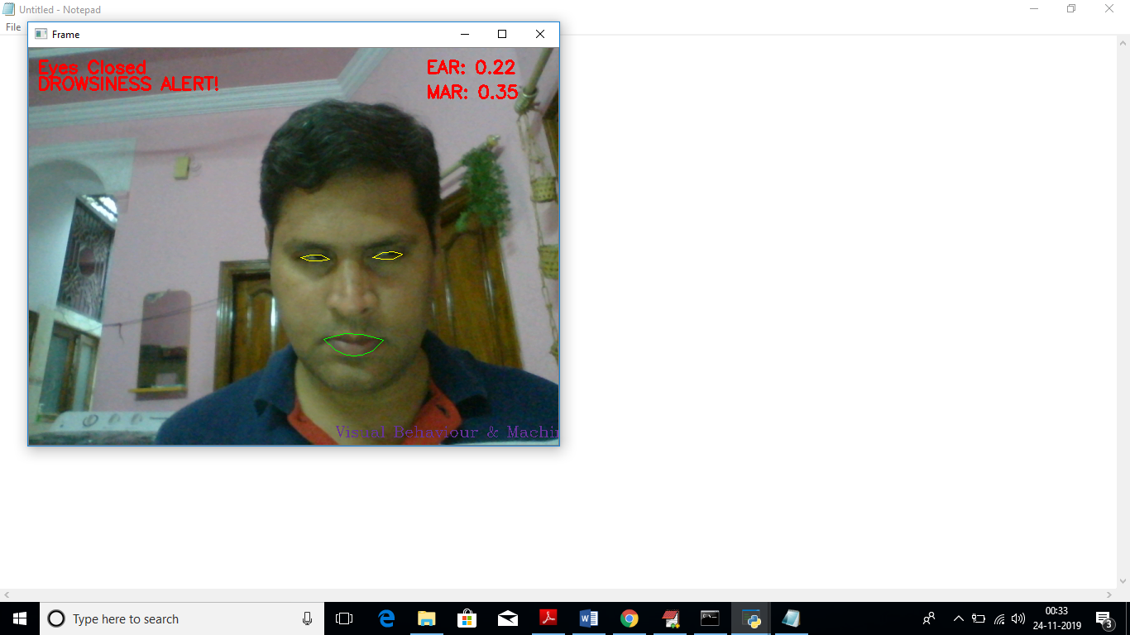

Similarly if mouth starts yawn then also will get alert message

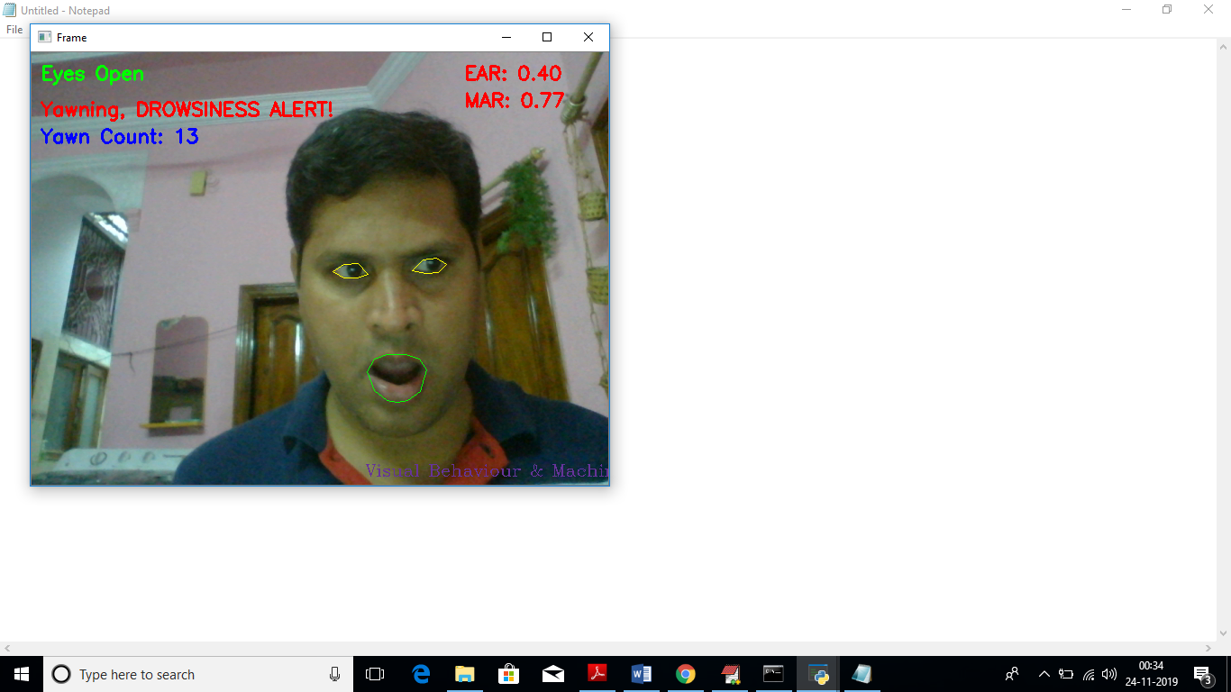

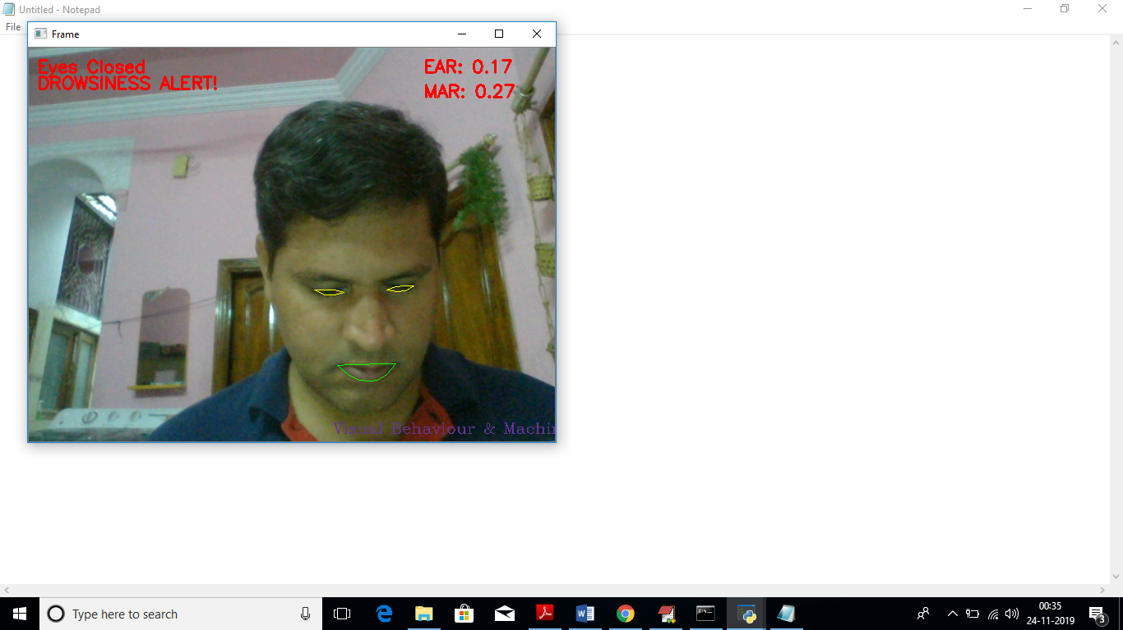

**11. FUTURE ENHANCEMENT**

A system in which density of traffic is measured by comparing captured image with real time traffic information against the image of the empty road as reference image is proposed. Each lane will have a minimum amount of green signal duration allocated. According to the percentage of matching allocated traffic light duration can be controlled.

**12. CONCLUSION**

In this paper, a low cost, real time driver drowsiness monitoring system has been proposed based on visual behavior and machine learning. Here, visual behavior features like eye aspect ratio, mouth opening ratio and nose length ratio are computed from the streaming video, captured by a webcam. An adaptive thresholding technique has been developed to detect driver drowsiness in real time. The developed system works accurately with the generated synthetic data. Subsequently, the feature values are stored and machine learning algorithms have been used for classification. Bayesian classifier, FLDA and SVM have been explored here. It has been observed that FLDA and SVM outperform Bayesian classifier. The sensitivity of FLDA and SVM is 0.896 and 0.956 respectively whereas the specificity is 1 for both. As FLDA and SVM give better accuracy, work will be carried out to implement them in the developed system to do the classification (i.e., drowsiness detection) online. Also, the system will be implemented in hardware to make it portable for car system and pilot study on drivers will be carried out to validate the developed system.

**13. BIBLIOGRAPHY**

[1] W. L. Ou, M. H. Shih, C. W. Chang, X. H. Yu, C. P. Fan, "Intelligent Video-Based Drowsy Driver Detection System under Various Illuminations and Embedded Software Implementation", 2015 international Conf. on Consumer Electronics - Taiwan, 2015.

[2] W. B. Horng, C. Y. Chen, Y. Chang, C. H. Fan, “Driver Fatigue Detection based on Eye Tracking and Dynamic Template Matching”, IEEE International Conference on Networking,, Sensing and Control, Taipei, Taiwan, March 21-23, 2004.

[3] S. Singh, N. P. papanikolopoulos, “Monitoring Driver Fatigue using Facial Analysis Techniques”, IEEE Conference on Intelligent Transportation System, pp 314-318.

[4] B. Alshaqaqi, A. S. Baquhaizel, M. E. A. Ouis, M. Bouumehed, A. Ouamri, M. Keche, “Driver Drowsiness Detection System”, IEEE International Workshop on Systems, Signal Processing and their Applications, 2013.

[5] M. Karchani, A. Mazloumi, G. N. Saraji, A. Nahvi, K. S. Haghighi, B. M. Abadi, A. R. Foroshani, A. Niknezhad, “The Steps of Proposed Drowsiness Detection System Design based on Image Processing in Simulator Driving”, International Research Journal of Applied and Basic Sciences, vol. 9(6), pp 878-887, 2015.

[6] R. Ahmad, and J. N. Borole, “Drowsy Driver Identification Using Eye Blink Detection,” IJISET - International Journal of Computer Science and Information Technologies, vol. 6, no. 1, pp. 270-274, Jan. 2015.

[7] A. Abas, J. Mellor, and X. Chen, “Non-intrusive drowsiness detection by employing Support Vector Machine,” 2014 20th International Conference on Automation and Computing (ICAC), Bedfordshire, UK, 2014, pp. 188- 193.

[8] A. Sengupta, A. Dasgupta, A. Chaudhuri, A. George, A. Routray, R. Guha; "A Multimodal System for Assessing Alertness Levels Due to Cognitive Loading", IEEE Trans. on Neural Systems and Rehabilitation Engg., vol. 25 (7), pp 1037-1046, 2017.

[9] K. T. Chui, K. F. Tsang, H. R. Chi, B. W. K. Ling, and C. K. Wu, “An accurate ECG based transportation safety drowsiness detection scheme,” IEEE Transactions on Industrial Informatics, vol. 12, no. 4, pp. 1438- 1452, Aug. 2016.

[10] N. Dalal and B. Triggs, “Histograms of Oriented Gradients for Human Detection”, IEEE conf. on CVPR, 2005.

[11] V. Kazemi and J. Sullivan; "One millisecond face alignment with an ensemble of regression trees", IEEE Conf. on Computer Vision and Pattern Recognition, 23-28 June, 2014, Columbus, OH, USA.

[12] Richard O. Duda, Peter E. Hart, David G. Stork, “Pattern Classification”, Wiley student edition. [13] Dataset: https://sites.google.com/site/invedrifac/